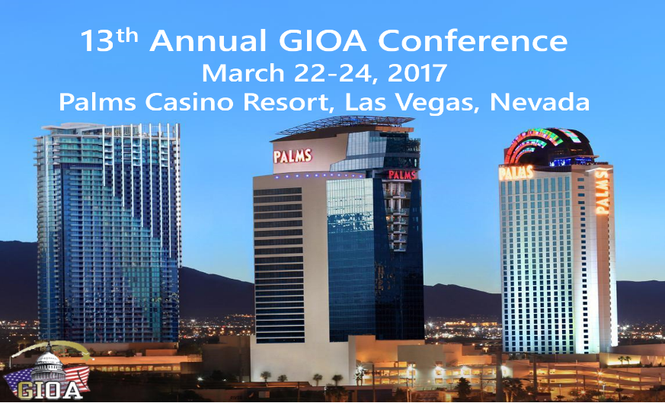

**Business Name:____________________________**

**Contact Name:_____________________________**

**Product Description:________________________**

**Email:____________________________________**

**Mailing Address:___________________________**

**City:_____________ State:______Zip:__________**

**Phone:____________________________________**

Exhibitor Benefits $2,000

**Contact Jennifer Felger at** [**jen.felger@gioa.us**](mailto:jen.felger@gioa.us) **or 702-561-8264 for any questions regarding the exhibitor application.**

Exhibitor space is available to promote products such as trading platforms or investment accounting and analytical systems on an eight-foot table top display

* **One free conference registration**
* **Company’s name and logo promoted on a sign at the conference**
* **Company’s name listed on the website**
* **Logo on conference t-shirt**
* **Provide giveaway item for conference attendees**
* **Attendee list prior to conference**

**Please make check payable and mail to:**

**Government Investment Officers Association**

**10655 Park Run Dr.**

**Ste. 120**

**Las Vegas, NV 89144**

2017 Conference

Exhibitor Application

Government Investment Officers Association