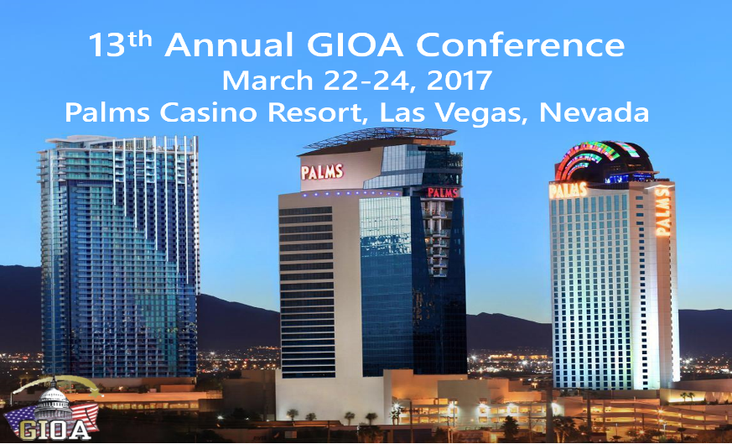

_______**Platinum $4,000** _______**Gold $2,000**

**Business Name:____________________________**

**Contact Name:_____________________________**

**Email:____________________________________**

**Mailing Address:__________________** **_________**

**City:_____________ State:______Zip:__________**

**Phone:____________________________________**

**Please make check payable and mail to:**

**Government Investment Officers Association**

**10655 Park Run Dr.**

**Ste. 120**

**Las Vegas, NV 89144**

**Platinum Sponsorship $4,000**

**Gold Sponsorship $2,000**

* **Two free conference registrations**
* **Company’s name and logo promoted on the largest sign at the conference**
* **Company’s name listed on the website**
* **Logo on conference t-shirt**
* **Provide giveaway item for conference attendees**
* **Attendee list prior to conference**
* **Company’s name and their representative announced at the conference**
* **Place cards with logos represented at lunch tables**
* **Opportunity to give away a prize**
* **Visual display of logo during conference breaks**

for

* **One free conference**

**registration**

* **Company’s name and logo promoted on a sign at the conference**
* **Company’s name listed on the website**
* **Logo on conference t-shirt**
* **Provide giveaway item for conference attendees**
* **Attendee list prior to conference**

**Contact Jennifer Felger at** [**jen.felger@gioa.us**](mailto:jen.felger@gioa.us) **or 702-561-8264 for any questions regarding sponsorship.**

2017 Conference

Sponsorship Opportunities

Government Investment Officers Association